Chinese President Xi JinpinghonoursCREG with Zhengzhou Factory Visit

Chinese President Xi JinpinghonouredCREG by visiting the TBM assembly factory at Zhengzhou on Saturday 10th May 2014. According to the Chinese press President XiJinping “ lauded the independent innovation at the China Railway Engineering Equipment Group Co., Ltd.(CREG)” during his inspection of the factory’s facilities.

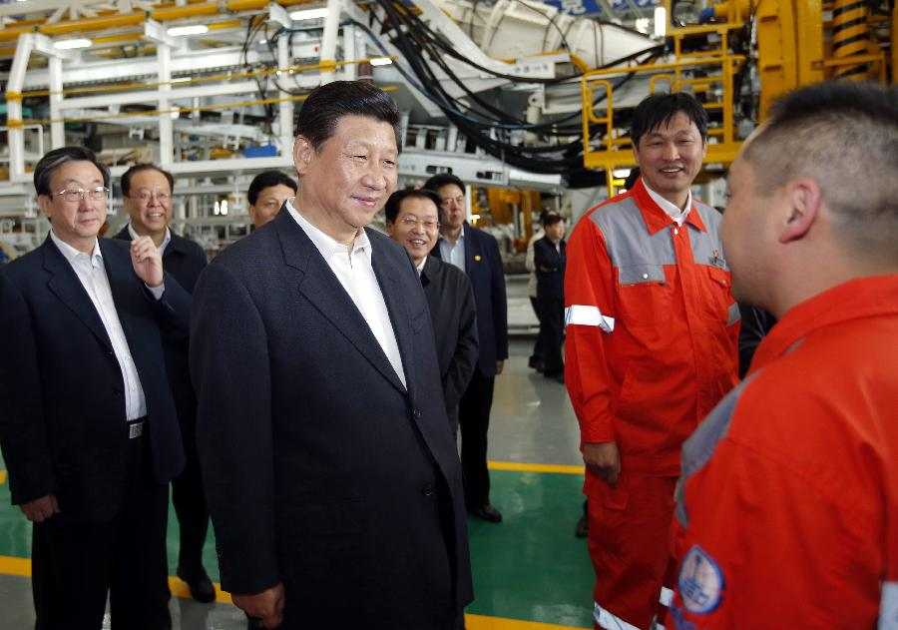
Picture : Chinese President Xi Jinping with CREG Chairman Li looking on.

The fact that CREG has been singled out for such a prestigious visit shows that CREG has been accepted as the leading Chinese International TBM brand.

CREG can supply TBMs internationally and providing an experienced and international source for these high quality machines. They are able to supply slurry tunnelling machines, - CREG recently received an order for Slurry machines for the Wuhan Metro - and Hard Rock tunnelling machines, based on the WIRTH technology which has recently been acquired a well as EPB machines for which over 140 orders have been received in the last 4 years including machines currently working on the Klang Valley MRT in Malaysia. Along with CTE Ltd, are also able to supply full after sale support, including on-site field service using both Chinese and ex-pat skilled technicians.

All enquiries should be addressed to:

sunheng@crectbm.com

China Railway Engineering Equipment GroupCo.Ltd. (CREG)

No.99,6th avenue, Zhengzhou, China
Tel:+86 (0) 371 60608991
Fax :+86 (0) 371 60608819
website: www.crectbm.com

Or

enquiries@cte-limited.com

CTE Ltd.
Unit 908, Block B, PhileoDamansara II
No.15, Jalan 16/11 off JalanDamansara
Section 16, 46350 Petaling Jaya
Selangor, Malaysia
Tel : +603 7954 0314
Fax : +603 7931 1977

